

S.B. JAIN INSTITUTE OF TECHNOLOGY MANAGEMENT & RESEARCH, NAGPUR

Practical 03

**Aim:** Automate student marksheet generation, system information display, Fibonacci and prime number generation, and file management operations using shell scripts to enhance computational efficiency and user interaction.

**Name: Yash Ganeshkumar Yeole**

**USN:CM24058**

**Semester / Year:4th/2 Academic Session:**

**Date of Performance: Date of Submission:**

* **Aim:** Automate student marksheet generation, system information display, Fibonacci and prime number generation, and file management operations using shell scripts to enhance computational efficiency and user interaction.
* **Tasks to be done in this Practical.**

1. Write a shell script to generate mark- sheet of a student. Take 3 subjects, calculate and display total marks, percentage and Class obtained by the student.
2. Write a menu driven shell script which will print the following menu and execute the given task.
   * Display calendar of current month.
   * Display today’s date and time.
   * Display usernames those are currently logged in the system.
   * Display your terminal number
3. Write a shell script which will generate first n Fibonacci numbers like: 1, 1, 2, 3, 5, 13
4. Write a shell script which will accept a number b and display first n prime numbers as output.
5. Write menu driven program for file handling activity
   * Creation of file.
   * Write content in the file.
   * Upend file content.
   * Delete file content

* **Objectives:**
  1. Automate marksheet generation with total, percentage, and class classification.
  2. Develop menu-driven scripts for system information and file operations.
  3. Generate Fibonacci and prime numbers for user-defined inputs.
* **Requirements:**
* **Hardware Requirements:**
* Processor: Minimum 1 GHz
* RAM: 512 MB or higher
* Storage: 100 MB free space
  + **Software Requirements:**
* Operating System: Linux/Unix-based
* Shell: Bash 4.0 or higher
* Text Editor: Nano, Vim, or any preferred editor
* **Theory:**

Shell scripting is a powerful way to automate repetitive tasks and manage system operations efficiently. It allows users to write programs using shell commands and scripting constructs. Shell scripts are interpreted line-by-line by a shell interpreter, making them ideal for administrative tasks, file management, and system automation. This practical encompasses a variety of real-world scenarios that demonstrate the utility of shell scripting for computing tasks and resource management.

1. **Marksheet Generation**

This script takes input marks for three subjects, calculates the total marks, percentage, and determines the class of the student based on predefined conditions. Conditional statements (if-else) are used to classify the performance into distinction, first class, second class, or fail. This exercise emphasizes the use of arithmetic operations and decision-making constructs.

Key concepts include:

* + Reading user input using read
  + Arithmetic operations with $((expression))
  + Conditional statements for decision-making

1. **Menu-Driven Script for System Information**

Menu-driven scripts enhance user interaction by presenting a list of options for performing different tasks. In this practical, options are provided to display the calendar of the current month, the current date and time, logged-in users, and the terminal number. The script utilizes looping constructs (while) and case statements for structured flow control.

**Commands used:**

* + cal for displaying the calendar
  + date for showing current date and time
  + who to list logged-in users
  + tty to identify the terminal

1. **Fibonacci Number Generation**

Fibonacci numbers are a sequence where each term is the sum of the two preceding ones. The script uses iterative constructs (for loop) to generate n terms based on user input. This practical illustrates the use of loop control and variable swapping to generate series data efficiently.

1. **Prime Number Display**

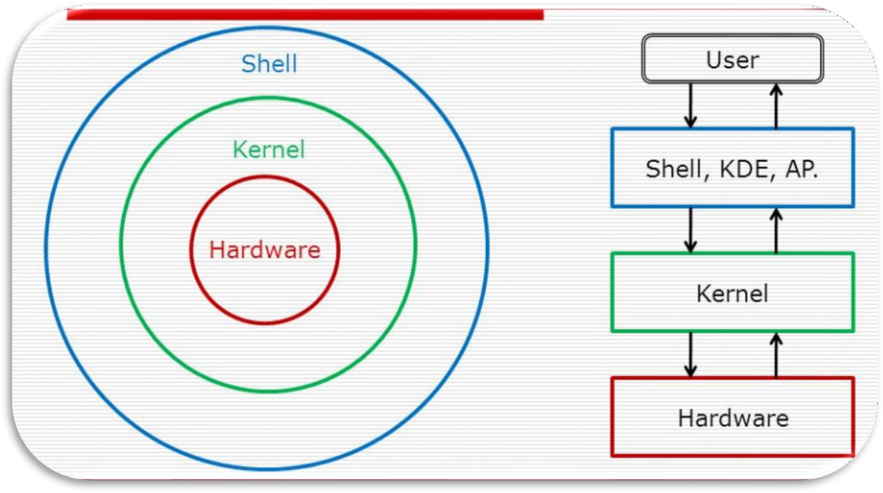

This script accepts an integer n and outputs the first n prime numbers. A nested loop checks divisibility to determine if a number is prime. The practical demonstrates logic building for number-theoretic operations using loops and conditionals.

1. **Menu-Driven File Management**

The file handling script enables users to create, write, append, and delete file content. The case construct manages different file operations.

Commands include:

* + touch to create files
  + cat for writing and appending content
  + rm for deleting files

This exercise emphasizes text manipulation, input handling, and file control mechanisms in Unix-like environments.

**Diagrammatical View of Shell**

* **CODES**

1. **Write a shell script to generate mark- sheet of a student. Take 3 subjects, calculate and display total marks, percentage and Class obtained by the student.**

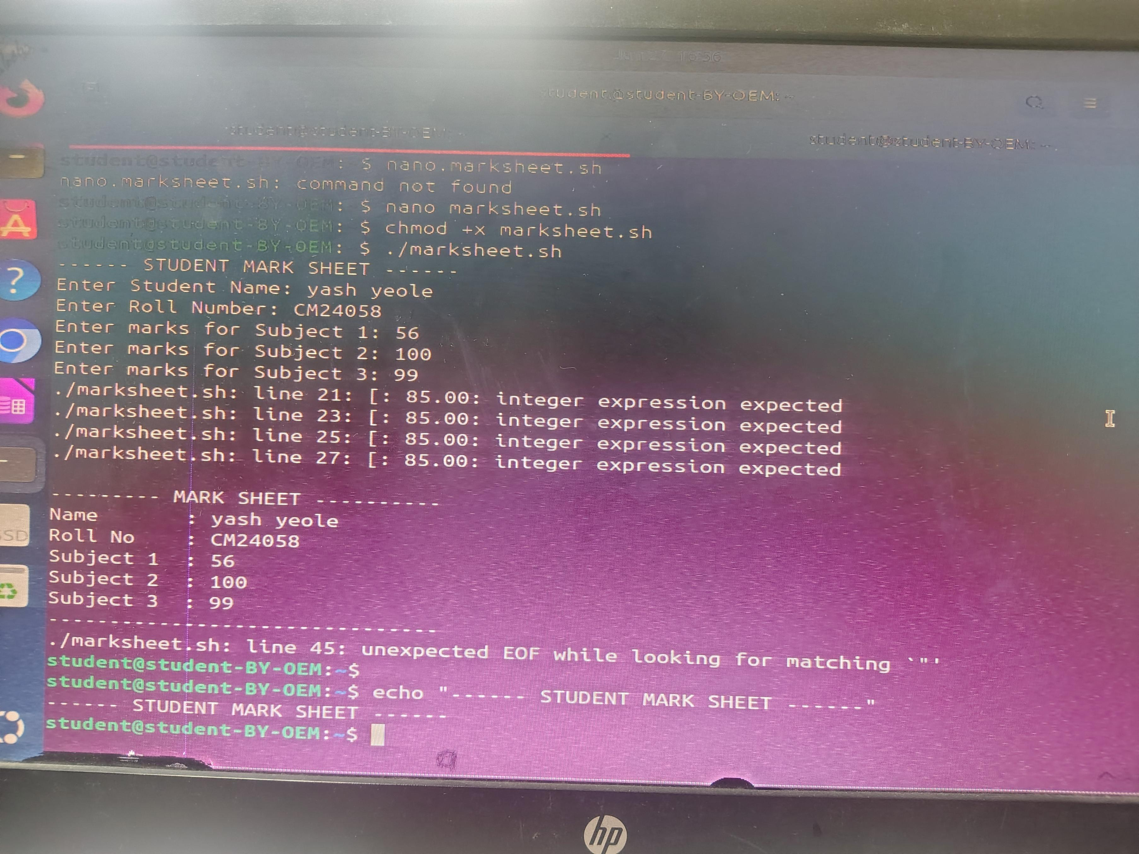**Output 1:**

1. **Write a menu driven shell script which will print the following menu and execute the given task.**
   * **Display calendar of current month.**
   * **Display today’s date and time.**
   * **Display usernames those are currently logged in the system.**
   * **Display your terminal number**

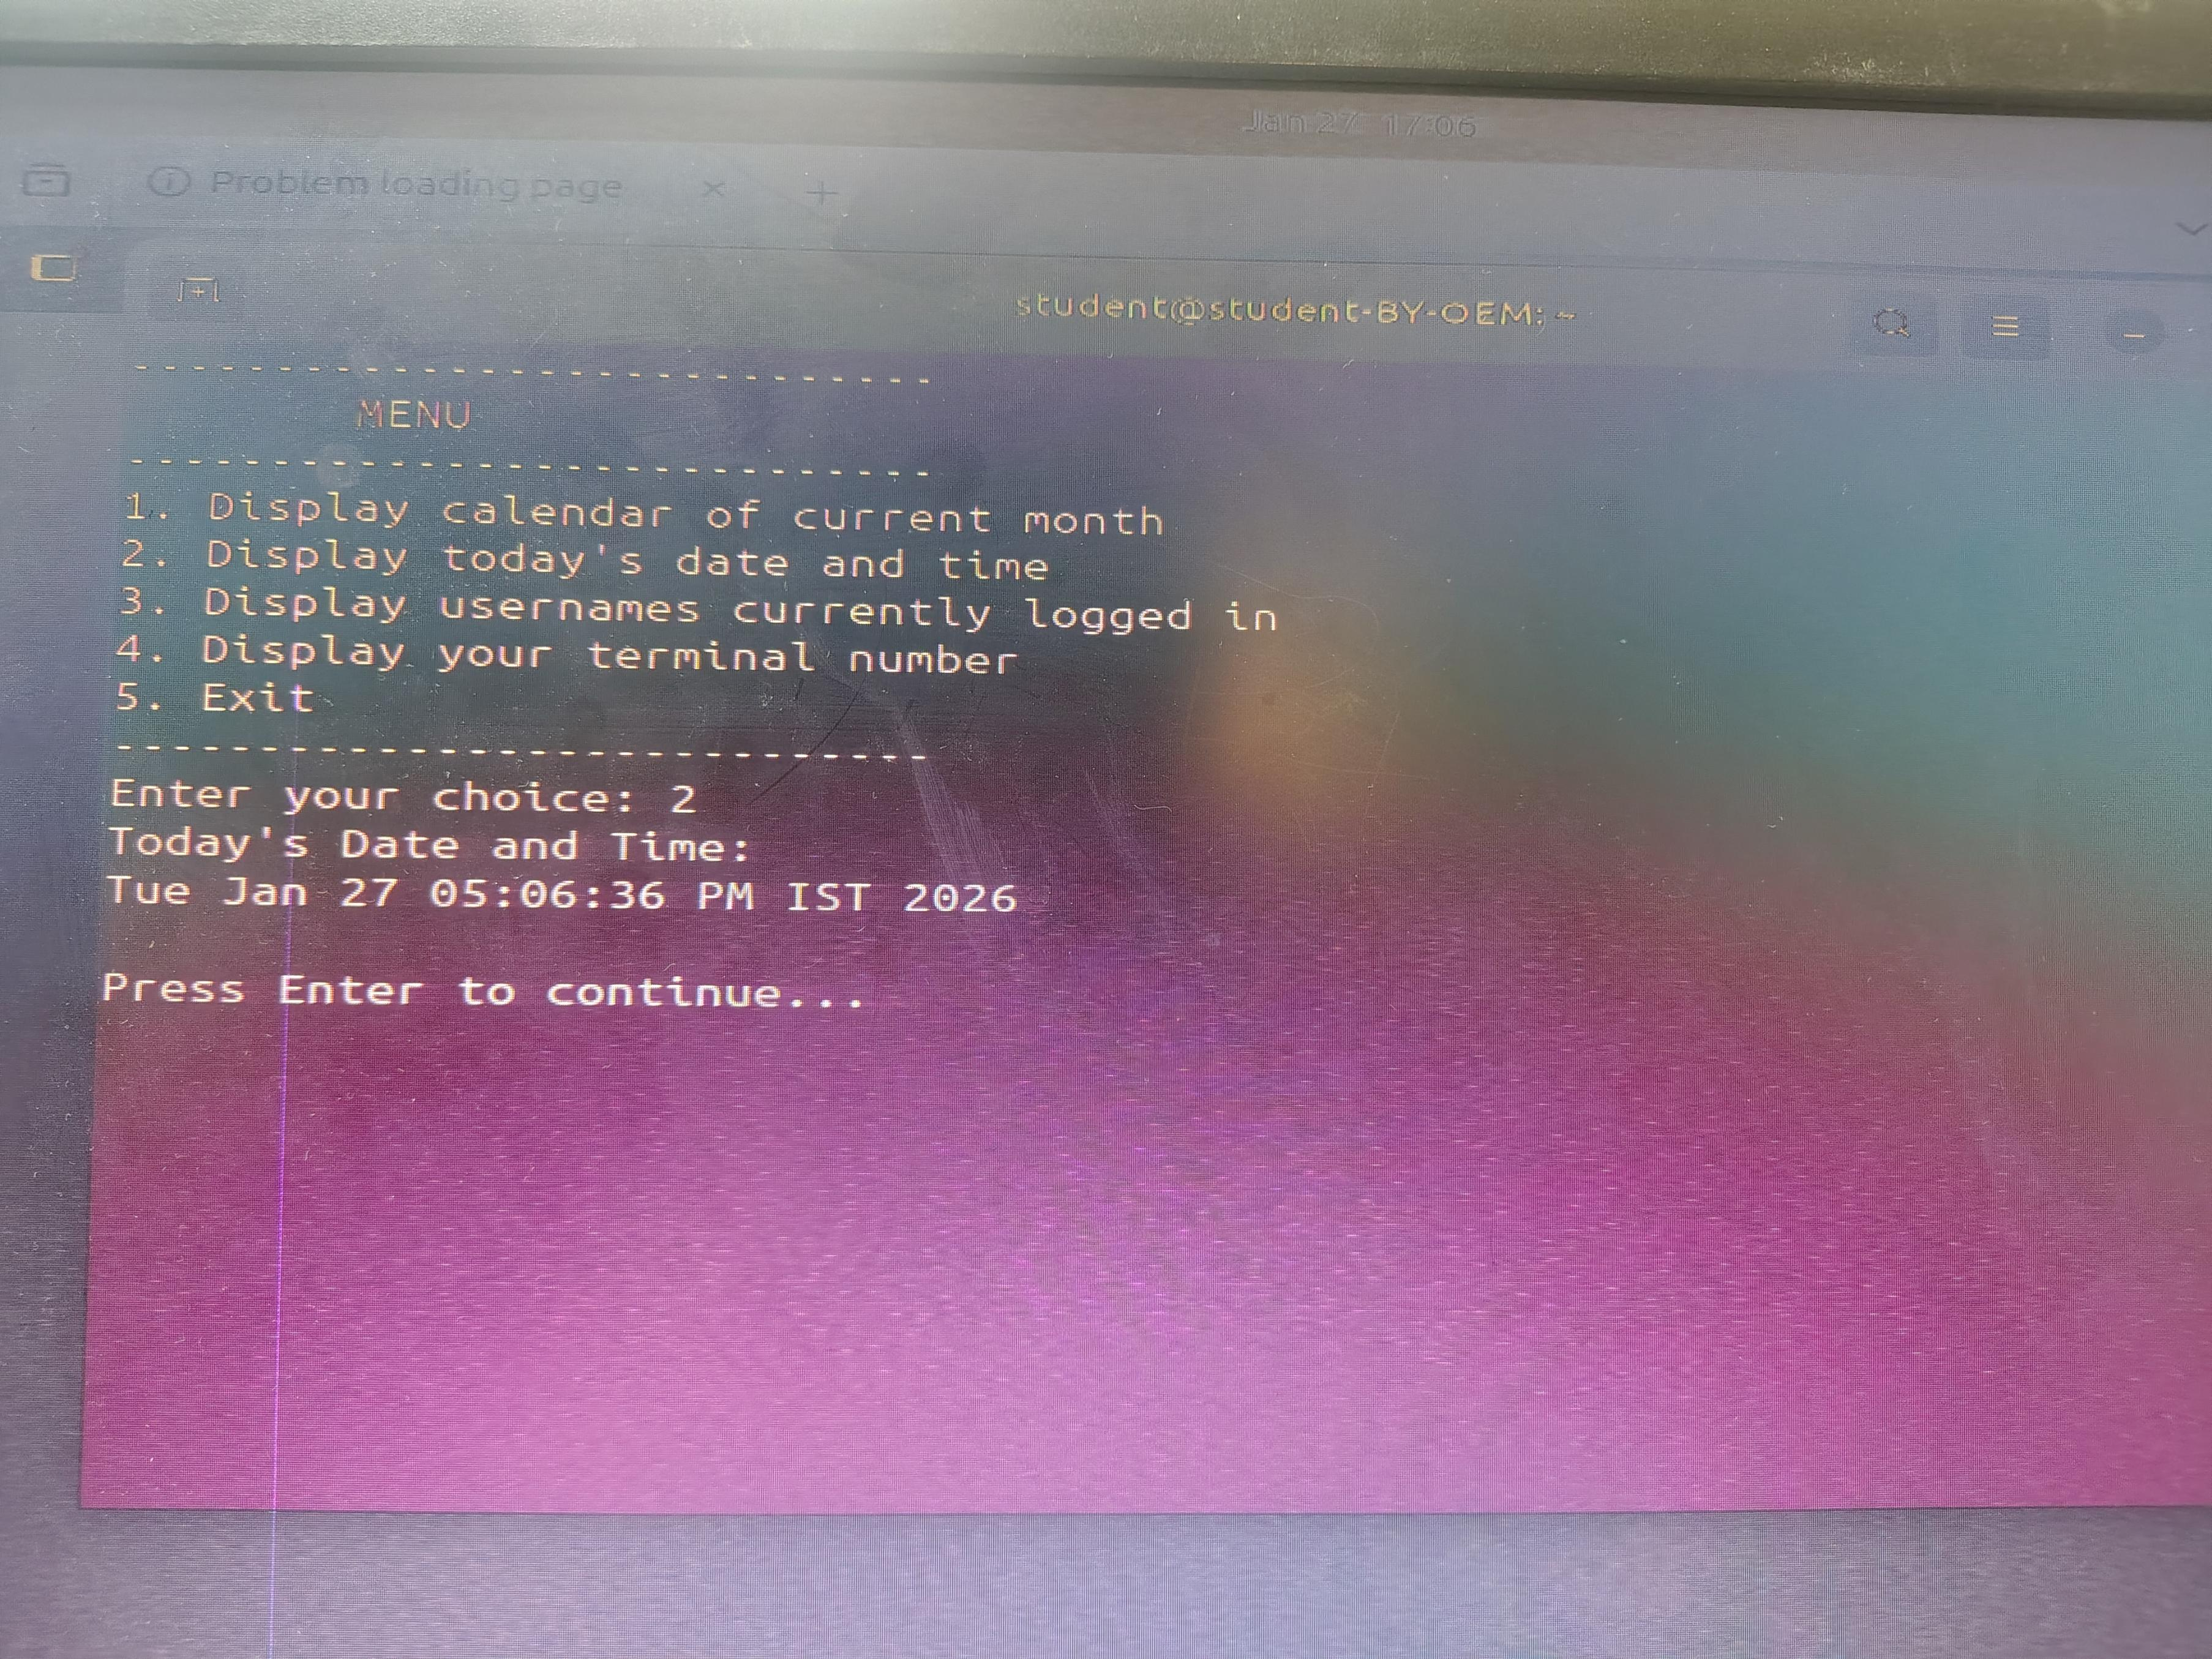**Output 2:**

1. **W rite a shell script which will generate first n Fibonacci numbers like: 1, 1, 2, 3, 5, 13**

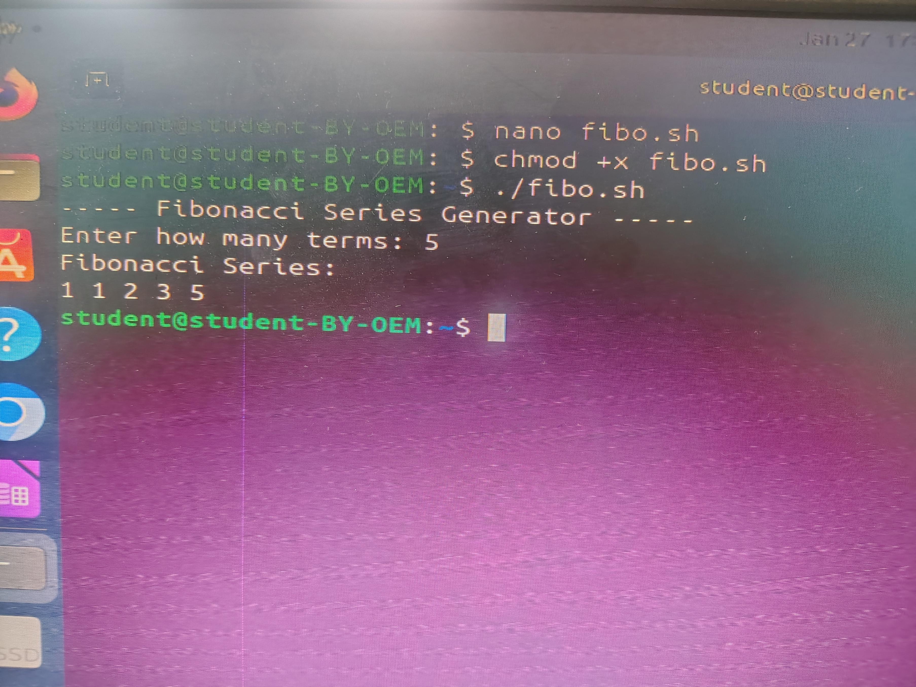**Output 3:**

1. **Write a shell script which**

**will accept a number b and display first n prime numbers as output.**

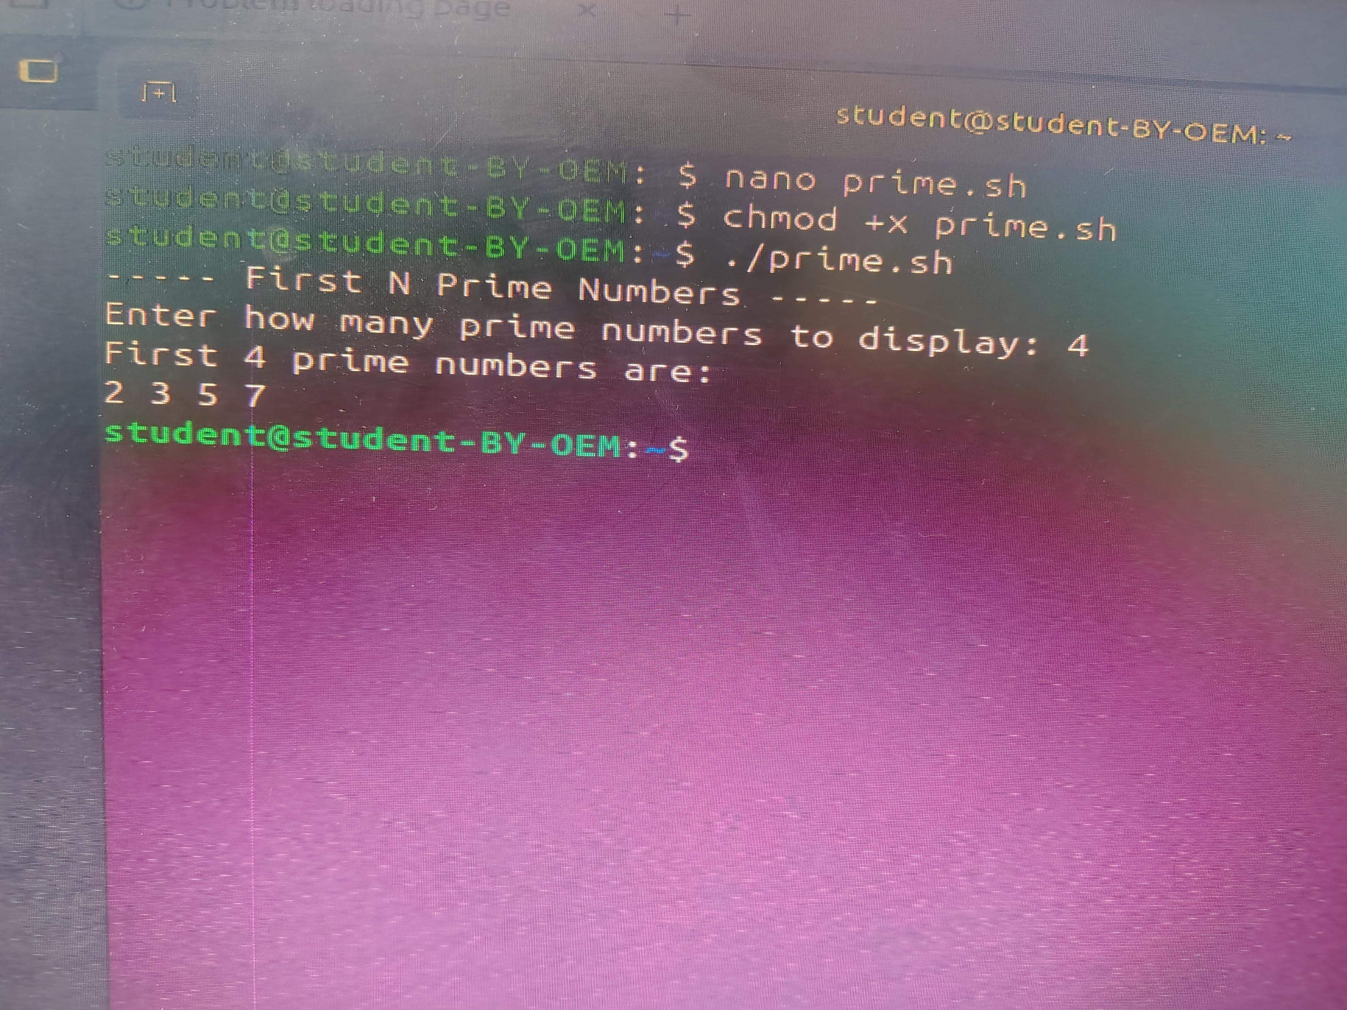**Output 4:**

1. Write menu driven program for file handling activity
   * Creation of file.
   * Write content in the file.
   * Upend file content.
   * Delete file content

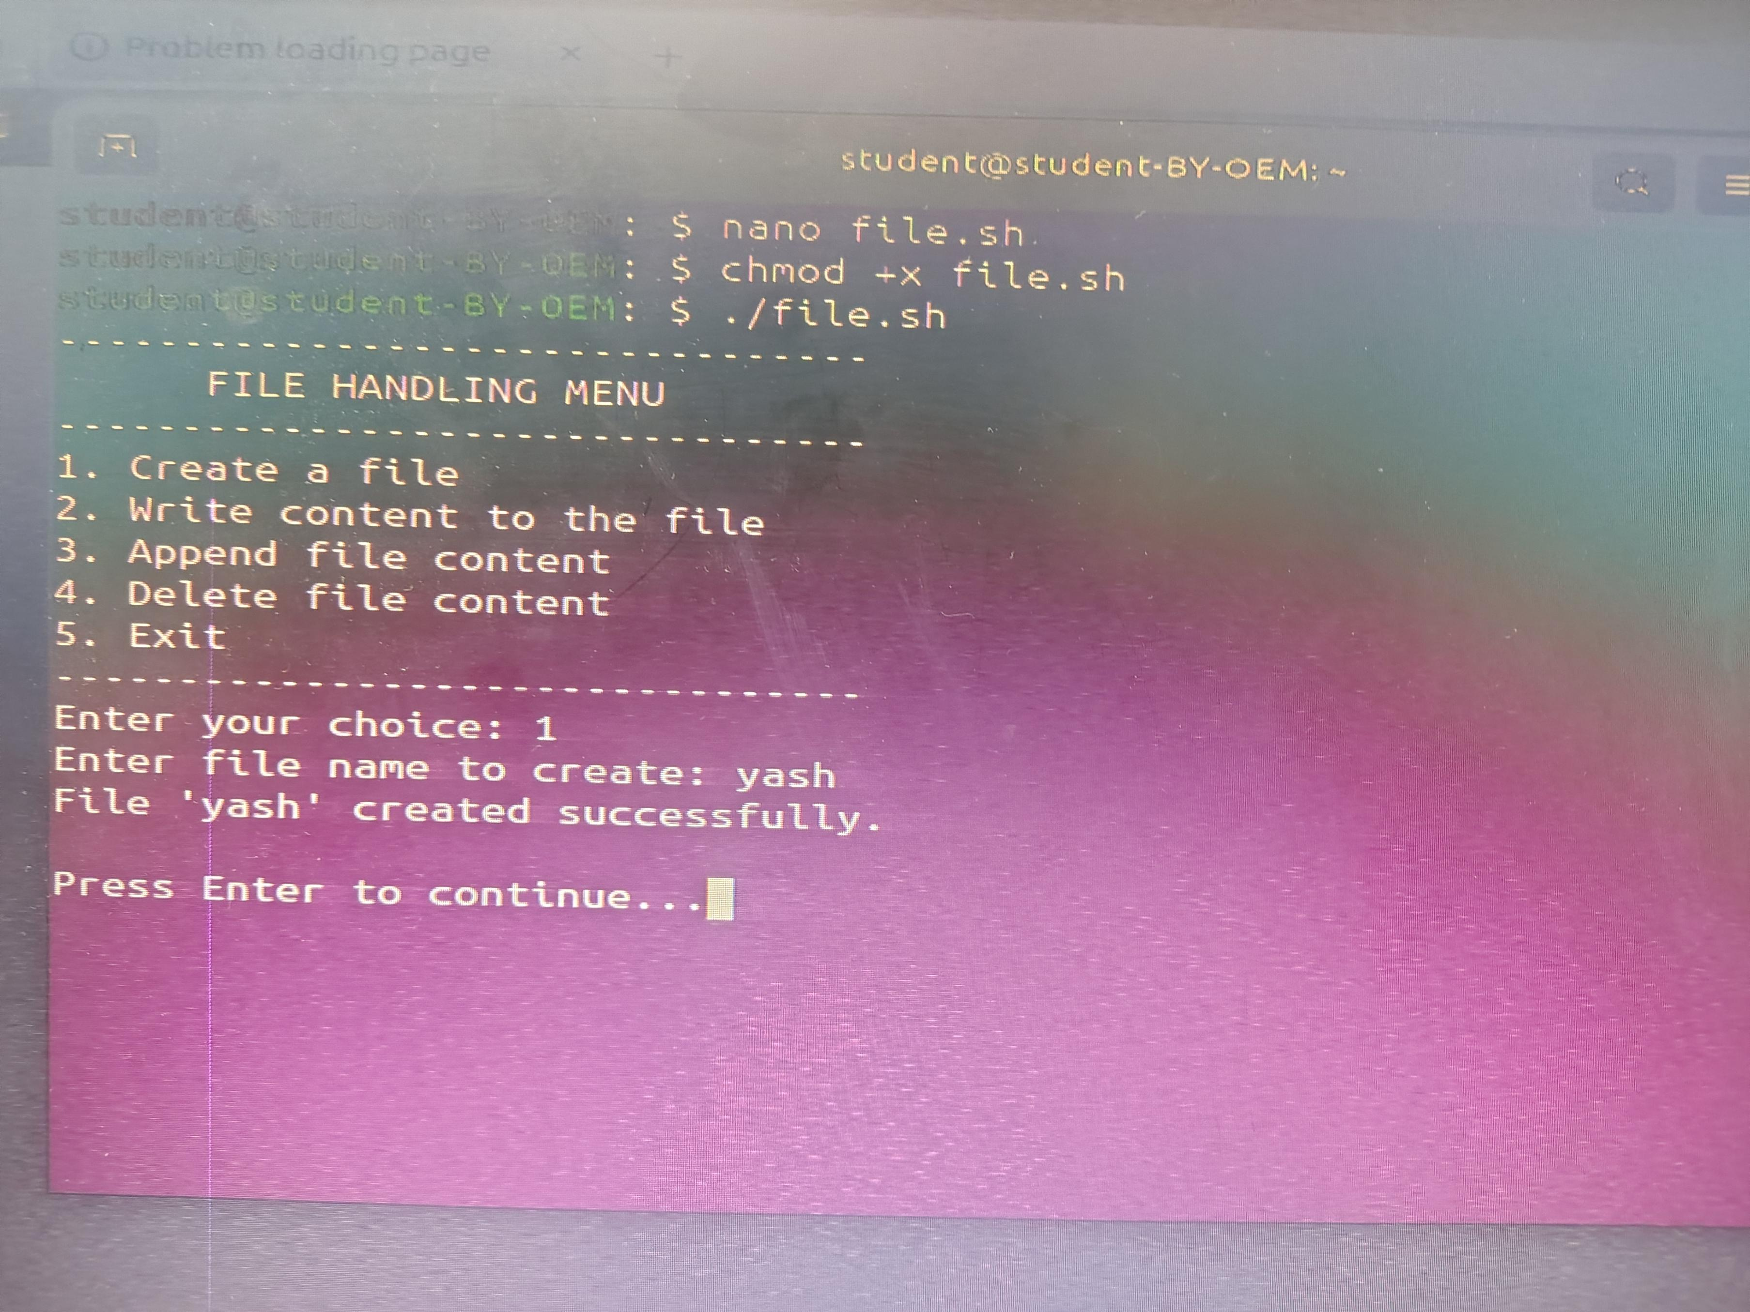**Output 5:**

* **Conclusion**: In this practical, we conclude that shell scripting efficiently automates tasks like marksheet generation, system information display, number computations, and file management, enhancing system operations and user interaction through command-line utilities.
* **Discussion Questions:**

1. **What is the purpose of using shell scripting in this practical?**
2. **Which command is used to display the current date and time?**
3. **How does the script calculate the Fibonacci sequence?**
4. **Which command is used to create a file in the file management script?**
5. **How does the prime number script determine if a number is prime?** 
   * **References:** *https://*[*www.tutorialspoint.com/unix/shell_scripting.html*](http://www.tutorialspoint.com/unix/shell_scripting.html) *https://*[*www.javatpoint.com/shell-scripting-tutorial*](http://www.javatpoint.com/shell-scripting-tutorial)

**Date:** **/ /2026 Signature**

Course Coordinator B.Tech CSE(AIML)